

Mechanical and Aerospace Engineering

650:468 Design and Manufacturing II

**FINAL DESIGN REPORT**

***for***

**The Solar Distiller**

|  |  |
| --- | --- |
| ***Group Number:*** | G4 |
| ***Advisor:*** | Professor Zhixiong Guo |
| ***Group Leader:*** | Michael Parry |
| ***Financial Officer:*** | Shaun Spitzer |
| ***Group Members:*** | Ryan Kim  Daniel Bouliga  Migguel Valdez |



Table of Contents

EXECUTIVE SUMMARY 3

STATEMENT OF THE PROBLEM 4

DESIGN OBJECTIVES 5

DESIGN PROCESS 5

FINAL DESIGN 7

ENGINEERING ANALYSIS OF FINAL DESIGN 9

OPERATION OF FINAL DESIGN 13

CONCLUSION 14

REFERENCES 15

Appendix A1. PROJECT MANAGEMENT 16

Appendix A2. BUSINESS MODEL CANVAS 18

Appendix B. PARTS LIST/BUDGET 21

Appendix C. DRAWINGS 22

# EXECUTIVE SUMMARY

Our project revolves around the design of a standalone solar powered water distiller used to purify/desalinate water for personal use. Our design involves a single container or pot of dirty/salt water surrounded by three parabolic mirrors. The pot is then heated through the collected sunlight, causing the dirty/salt water to boil into steam and evaporate. The steam is then collected in a separate container and cooled in the condenser, leaving distilled water for drinking use.  
  
The hand-made mirrors are set up around the pot using stands that can be adjusted as the sun changes location, providing optimal sunlight intake throughout the day. These mirrors reflect and focus solar irradiation onto the pot to heat up the pot effectively, resulting in quick boiling of water. Additionally, the pot is properly insulated to retain heat and further reduce the water’s boiling time.  
  
With increasing fresh water shortages in certain areas of the world, our group decided that it would be viable to make a standalone solar distiller for areas with ample sunlight and salt water/dirty water in order to provide more access to clean drinking water to populations that do not have access to it. This product is mainly for personal use, given the portable design and easy setup.   
  
Through extensive testing and optimizations, enough water can be obtained to roughly fill a standard water bottle in about an hour of the project’s operation. The water can be consumed directly without any noticeable adverse effects. Optimizations included insulation of the pot and lid and reducing the height of the condenser to allow for the aid of gravity in water collection.

# STATEMENT OF THE PROBLEM

The Solar Distiller is meant to provide environmentally friendly relief for people/communities that do not have access to clean drinking water. Both water scarcity and greenhouse gas emissions have been growing concerns throughout the planet, creating a great need for an immediate solution. The Solar Distiller is an attempt to address both of these issues by helping the victims of water scarcity with a product that runs entirely on solar energy.

Right now, over 20% of the world’s population is in an area suffering from a shortage of fresh water, and that number is expected to increase in the coming years. According to the United Nations, “By 2025, 1.8 billion people will be living in countries or regions with absolute water scarcity, and two-thirds of the world's population could be living under water stressed conditions” [1]. While the spike in demand for fresh water could be a result of uneven distribution, wasteful tendencies or unsustainable management, the source of water scarcity this project focuses on addressing is economic water shortage. This is when a country has access to water from rivers, lakes, or the ocean, but lacks the necessary infrastructure to purify that water. This is mostly dominant in countries throughout Africa.

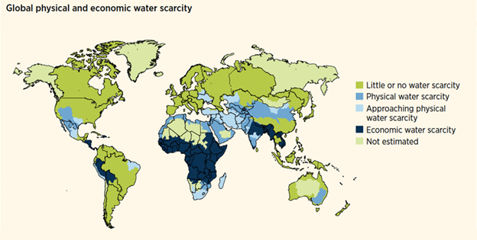

While the long-term solution to this problem is to build the necessary infrastructure for those countries, the dramatic effects of water scarcity call for a more immediate solution. Economic water scarcity forces the use of unsanitary water sources, and in the book “Computing in Research and Development in Africa”, it is estimated that in Saharan Africa “over 4,100 children die everyday due to dirty water” [3]. When countries don’t have access to clean water, there are detrimental consequences for the health and safety of its inhabitants. These immediate health concerns, caused by growing water scarcity, call for a short-term solution that can provide fresh drinking water for individuals in need.

The environmental impact of the way this fresh water is provided is of equal importance. It is possible to boil water by burning wood rather than using mirrors, but this method would not only be difficult to maintain, it would also be unideal for the future scope and shift to clean energy. CO is one of the primary greenhouse gases emitted through human behavior, and in the year 2017, surprisingly, wood was one of the number one contributors in the state of New Jersey. While coal, oil and natural gas are the main concern worldwide when looking to decrease emissions, it is important to recognize that wood burning is also capable of emitting CO and subsequently harming the environment. The surge for solar and other renewable energy all together calls for more active solutions that utilize clean resources and the Solar Distiller could be the cleanest relief product on the market.

# DESIGN OBJECTIVES

We are going to design and manufacture a water distillation device. With the creation of this device we aim to achieve the following objectives:

1. Optimize the amount of water that can be distilled in the shortest period of time.
2. Choose the appropriate materials to maximize heat transfer
3. Design and construct three highly emissive, concave mylar mirrors that can properly direct sunlight onto the water reservoir.
4. Maintain a portable design through the use of lightweight components that can be set up and operated within the confines of a meter squared working space

# DESIGN PROCESS

The design process for the Solar Distiller took on two main stages. Through the trial and error of different design ideas, we were able to eventually come to an agreement on the best idea, while learning a significant amount about the practicality in applying the methods we learned in our engineering courses.

**BIG PICTURE**

The conceptual design of the Solar Distiller went through many phases before it could be finalized. The original project idea was far different than it is now. The device was meant to be a concentrated solar collector using parabolic mirrors and a connected cooling system capable of storing excess heat for other applications such as heating and desalination. This project idea was based on IBM’s current research in Concentrator PhotoVoltaics (CPV). This design presented a great challenge of finding an appropriate fluid flow rate to keep the panels at the perfect temperature where they were operational, but hot enough to heat the water to a usable temperature of 80-90C. After calculating the amount of heat supplied by parabolic mirrors onto the solar panel, it became clear that the the type of solar panel we had access to was unable to perform past temperatures of around 70°C. Because of this limitation, without using an expensive microchannel cooling system or pushing the solar panel past operational temperature, it would be impossible to get cooling water runoff with high enough temperature for practical usage.

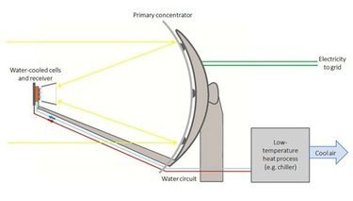

The second design included a solar panel on the underside of a water reservoir, meant to collect solar energy from parabolic mirrors while simultaneously heating the water above to facilitate a distillation process. The possibility of this design was analyzed using concepts in heat transfer and fluid mechanics, but again we were faced with impracticalities. The design relies on evaporation of heated water, but again the solar panels temperature would be held constant at around 50 C for maximum efficiency. We found this operational temperature to be an impractical heat source for evaporating water over a short time scale. To keep either the fresh water quantity or the solar energy product high, our design would have to be either an overheated solar panel, or an extremely slow evaporation rate, respectively.

When analyzing the second design, we became aware of the massive amount of heat capable of collection from the mirrors, and the potential that heat had if it were directly applied to the water reservoir without the solar panel in the way. This led us to the the final idea of the Solar Distiller.

**EXECUTION OF DESIGN OBJECTIVES**

The first design objective involved maximizing the amount of water that we could realistically produce in a short period of time. The simplicity of the device calls for the type of product that can produce clean water in a timely manner without too much waiting and repositioning. To do this, we modeled the heat transfer to the water in MATLAB to get an idea of how long it would take to boil different amounts of water. As the initial volume increased, expectedly, the time to boil increased as well. Also, it proved to be more effective to have a water reservoir with a large surface area and relatively low depth. In order to meet both of these criteria, we chose a water reservoir that had a large diameter and was tall enough to fit a range of volumes. This will allow the user to use a small amount of water for quick results, or a large amount of water for slower results (yielding a larger fresh water product).

The second objective involved choosing materials for the entire design. For the water reservoir, we wanted something that could transfer the most amount of heat without being too expensive. We chose a black anodized aluminum pot, as its color and material properties gave us an ideal transfer of heat. For the mirrors, we needed to choose the most reflective material in order to maximize sunlight reflection. We chose on mylar because it is cheap and it’s reflectivity is 98% (only 2% losses).

The main design component is the three parabolic mirrors. When designing the distiller, we needed the mirrors to be large enough to reflect mass amounts of heat, while still being small and light enough to carry. To do this, we calculated the amount of heat we would get from each mirror as a function of diameter. This allowed us to compare the amount of heat desired to the appropriate mirror diameter. We found that using three 25 inch mirrors would be the optimal design in transferring heat in a portable but effective way.

Every component of the Solar Distiller fell under the idea that it needed to be portable and easily set up/deconstructed. The pot, mirrors and condenser had to be small enough to carry. Also to hold the pot/water reservoir, we purchased a steel tripod that is easily deconstructable. The portable nature of the design allows easy set up in under 10 minutes.

# FINAL DESIGN

The entirety of the planning and work done for this project all culminates to our final design, a solar distiller that works by using what is, perhaps, the most abundant and easiest to obtain energy. The desalination process runs under the power of the sun and only the sun. In order for this device to work quickly and efficiently, a certain setup is required in order to harvest the power of the sunlight.

The first important aspect of this device is the parabolic mirror. When put at the correct angle, this mirror will concentrate the sunlight and redirect it to a point to provide a large amount of heat energy. To provide a maximum amount of heat for the allotted budget, there will be three such mirrors. The biggest obstacle to overcome when designing the mirrors was how to do so cost effectively. Were we to buy the mirrors pre- assembled from a reputable source, we could have used up essentially the entire budget. To minimize cost, we will be using Mylar sheets as the reflective material. Mylar is an extremely reflective material and at a cost that is almost negligible, that is, compared to a preassembled mirror. The reflectivity of this material is extremely important as we do not want solar energy absorbed by the mirrors, this would lower the efficiency. These sheets will be cut into a circle, and the edges will be secured to a melamine coated particle board. A melamine particle board has been chosen because the seal between the Mylar and the board needs to be airtight. The melamine seals the pores of the board which will make this possible. A hole is then cut in the middle of the board and a bicycle valve stem is placed to make an air tight seal for an electric pump to attach. Using the pump, air will be added to the space between the board and the Mylar, creating a balloon of sorts. The resulting shape is a concave dome of Mylar. To keep the shape of this dome permanent, sheets of structural fiberglass and resin are added to the back of the exposed Mylar. Once the fiberglass is completely cured, the Mylar will be separated from the melamine coated board which will result in a concave Mylar mirror. The outer circumference of this mirror will finally be reinforced with landscaping edging. The other problem to consider with the mirrors, is the ability to adjust them. To remedy this, the mirrors will be placed on small tripods designed for microphones. This will provide the mirrors with a support system that also has a large amount of maneuverability. This system will make it extremely easy to adjust the angle of the mirrors as the sun is moving throughout the day. This entire process is completed three times, to provide three sources of focused heat to the boiler.

The next important part of the final design is the boiler. The boiler is the part that will hold and heat the salt water and cause it to boil. The boiler will be fashioned from an anodized aluminum pot. This material was chosen for three major reasons. The first reason is heat transfer, the second is corrosion resistance, the third is its reflection, or lack thereof. Aluminum cookware is used because it has a very high thermal conductivity, second only to copper, and other more expensive engineering materials. In addition, both aluminum and copper provide very even heating, it is not concentrated to one point. Although copper has better heat transfer than that of aluminum, it corrodes much more easily. Because the function of our product is to desalinate water, it is necessary to pick a material that can hold salt water for long periods of time without sacrificing its structural and chemical properties. Anodized aluminum has a rough, non-reflective coating unlike normal aluminum. This is caused by a thick layer of corrosion-resistant oxidized aluminum. This rough exterior provides the boiler with a decent ability to absorb the heat that is to be concentrated upon it. The physics of this distiller has a large amount to do with reflectivity. That is, the mirrors must be as reflective as possible to concentrate as much heat as possible onto the boiler, and the boiler must have very little reflectivity so that it may accept this energy source. A lid is then placed on top of the boiler that has a cutout to place a pipe. This is where the steam generated from the boiler will exit to be processed elsewhere. This lid is made out of silicone rubber, a thermally resistant and inert material. Because it is rubber, it will create an air-tight seal around the pot making it extremely easy to take off to add more water and adjust while still containing the steam created by the boiler. To finish the boiler, its exterior is painted black to increase the overall solar absorbance. Fiberglass insulation wrapped in Mylar is then applied to most of the exterior, saving one side of the pot to be exposed. The exposed side of the pot is where the mirrors are focused, and insulation will retain as much heat as possible on the surfaces not exposed to the mirrors.

After the water is put through the boiler, it will turn into steam. This steam will travel through the pipe that is attached to the lid, and bring it to the next part of the device, the condenser. The placement of the pipe is important, it must maintain an inverted U-shape. This will allow the steam to rise to the top, and then condense so that gravity will bring the back down into the condenser inlet to be processed further. The condenser is composed of a copper coil, where the steam will travel through, and an exterior cool water reservoir. The coil is made of copper because, as previously mentioned, copper has a very high coefficient of thermal transfer. This will allow the cool water that surrounds the coil to cool down the steam that travels throughout it and condense it. Before it was mentioned that copper corrodes very easily in the presence of salt water. This will not matter as the water the copper will be in contact with is distilled and free of essentially anything that copper will be able to react with. The cool water reservoir will be large, roughly 4 gallons, to provide the system with enough water where it will not heat up due to the steam travelling throughout the copper coil.

Once the water is cooled and condensed, it will travel through a pipe attached to the bottom of the condenser. From here, gravity will bring this water into another reservoir. In this reservoir will be clean, salt free, distilled water that is safe to drink and cook with. The end result is the ultimate goal of our design, and it will help those in areas with a large amount of sunlight and saltwater.

**ENGINEERING ANALYSIS OF FINAL DESIGN**

When determining the validity of the experiment, the objective must be proven possible; the water in the pot must evaporate fully and exit the system as condensed clean water. To start the thermodynamic process, the assumption made first is that the environmental conditions are of a typical sunny spring day in New Jersey; weather conditions of Rutgers Day 2017 are chosen. The conditions used are 66 degrees Fahrenheit (292K) air moving at 7m/s with a convection constant h = 30[W/m^2*K]. The radiation from sun is then estimated to be about 1000 kW/m^2. With an angle of 80 degrees between the sun and the 26”-diameter mirror reflection, the cross sectional area of light absorption/reflection is 1.247m^2. Since it is a parabolic mirror, all the reflection will be directed at one spot on the pot of water. With 3 mirrors, and our estimated loss due to imperfect reflectivity of the mirror, the total heat reflected at the pot of water is estimated to be 3.4851 kW. That is Q(radiation). The Q(convection) of air depends on the temperature difference between the inside of the pot and the outside air. The pot has a surface area of 0.38m^2. Calculating the boiling of 1 gallon of water is done on MATLAB using an MIT resource that gives the values of the heat of vaporization of seawater at varying salt densities (salinity). The initial salinity of seawater is 35g/kg, so 35 parts per thousand (ppt). This starts to decrease after water starts boiling and leaving the heated pot of saltwater. The validity of the MIT resource is limited to a salinity of 240g/kg, so a linear interpolation is used to calculate the rate of evaporation after that point for which that salinity is reached from evaporation. Latent heat is used as a function of temperature and salinity. Before the boiling point, it is simply a calculation of change in temperature as the heat rate divided by the initial mass times specific heat; this is done using Q(total) = Q(radiation) - Q(average convection from air temperature water to boiling temperature water). This determines the time it takes to start up the boiling from 21 degrees Celsius. Then individual rates of evaporation are used with the decreasing mass but constant temperature of 100 degrees Celsius. This means Q(total) is at its minimum since the temperature difference (between water and surroundings) is highest, so it is Q(radiation) minus Q(convection-max). MATLAB is useful for determining the total mass per time through simple iterative loops. The MATLAB code/calculations are as follows [where output is in purple text]:

The Startup to Boil........................................................................................................................... 1

Evaporation with MIT Enthalpy Functions..................................................................................... 1

Continued Evaporation beyond boundaries of MIT Functions........................................................ 2

Total Plot.......................................................................................................................................... 3

Correct/Experimental Plot................................................................................................................ 4

Comparison Plot............................................................................................................................... 5

## The Startup to Boil

% Temperature: 21 Celsius to BoilingPointTemperature BPT

BPT = 100 + SW_BPE(100,'C',35,'ppt'); %BPE-BoilPointElevation

m0= 3.79 ; %[kg] = 1 gallon water

Q = 3.4851; %[kW] Q: 3 (26"diam)-Mirrors, reflected with 80 degree angle from sunlight

Qavg = 3.0291; %[kW] average Q from Temp = 21 to 100 deg Celcius

% Qavg = Q(radiation) - Q(average convection from air)

% Air at 7m/s, 21 deg Celcius, h = 30[W/(m^2*K)]

% T(surface)-T(infinity) = [0:80] = dT

% Q(conv) = 30[W/(m^2*K)]*0.38(m^2)*dT

% Qavg = 3.4851 - .456 [kW] = 3.0291 for dT = 40K

dTdt = 1;

T0 = 21;

for i = 1:600

cp(i) = SW_SpcHeat(T0,'C',35,'ppt',101.325,'kPa'); % Specific Heat [J/kg-K]

dTdt(i) = (Qavg/m0)/(cp(i)/1000); %[C/s]

dTdt = [dTdt dTdt(i)];

T0 = T0+dTdt(i); %[C=C+(C/s)*1s]

if T0 > BPT

i; % each i is 1 second

break

end

end

T0;

% t0 = time [s] for 21 < T < Boiling

t0 = i; % 400 seconds to start boiling

fprintf('It takes %3.1f seconds to reach boiling temperature %3.1f degrees Celsius\n',t0,T0)

It takes 400.0 seconds to reach boiling temperature 100.6 degrees Celsius

## Evaporation with MIT Enthalpy Functions

m1=m0;

ppt = 35;

i = 1;

hfg = 1;

mass = m0;

Q1 = 2.5731; %[kW] while dT = 80K, so Q1 = Qrad - Qconv(max)

% For non constant Latent Heat, this is as far as the salinity limit allows

% for Evaporation at 100 degrees C

%fprintf('Mass(i+1) = Mass(i) - (d(Mass)/dt)*(1sec) :\n')

for i = 1:109

hfg(i) = SW_LatentHeat(BPT,'C',ppt,'ppt'); % Specific Latent Heat (Enthalpy of Vaporization) [J/kg]

dmdt(i) = Q1/(hfg(i)/1000); % dmdt = mass evaporation rate [kg/s]

m1 = m1 - dmdt(i)*1; %dmdt*1sec = dm

ppt = ppt*(m0/m1); % new ppt (salt g/kg)

hfg = [hfg 1];

dmdt = [dmdt 1];

t1 = i;

mass = [mass m1]; % Actual mass data collected;

%fprintf('%1.5f kg = %1.5f kg - %1.5f kg/s\n',mass(i+1),mass(i),dmdt(i))

end

t1; %109 seconds

fprintf('After %3.0f seconds, the remaining mass is %1.4f kg \n',t1,m1)

After 109 seconds, the remaining mass is 3.6546 kg

## Continued Evaporation beyond boundaries of MIT Functions

% Take dmdt(109) as mass evaporation rate with highest salinity; use this

% for the rest of the time, t3, as a constant linear slope.

% MIT Resource Conditions:

% VALIDITY: 0 < T < 200 C; 0 < S < 240 g/kg

% --> VALIDITY: T = [21:100] C; S(1) = 25 g/kg, S(47) = 240 g/kg

% ACCURACY: 0.01 %

m3=1:2459;

mass3 = m1;

for i = 1:2460

mass3 = mass3 - dmdt(109);

m3(i) = mass3;

if m3(i)<0

i

break

end

end

t3 = 2459; %[seconds] to fully evaporate

mass3;

fprintf('After %4.0f seconds, the final mass is %1.4f kg\nSo at %4.0f seconds, the mass is fully evaporated.',i,mass3,t3)

i =

2460

After 2460 seconds, the final mass is -0.0013 kg

So at 2459 seconds, the mass is fully evaporated.

## Total Plot

a = ones(1,400)*m0;

b = [a mass m3]; %kg-water in pot

b2 = 3.79-b; %kg-water evaporated

boz = b2*33.81402; %oz-water evaporated

x0 = (1/60)*[1:(400+110+2460)];

plot(x0,boz)

ylabel('Water Evaporated [oz]')

xlabel('Time [minutes]')

title('Evaporation of 1 gallon over Time')

timesec = t0+t1+t3

timemin = timesec/60

fprintf('With 3.4851 kW from the sun, Time to Full Evaporation is 49 minutes and 28 seconds')

timesec =

2968

timemin =

49.4667

With 3.4851 kW from the sun, Time to Full Evaporation is 49 minutes and 28 seconds

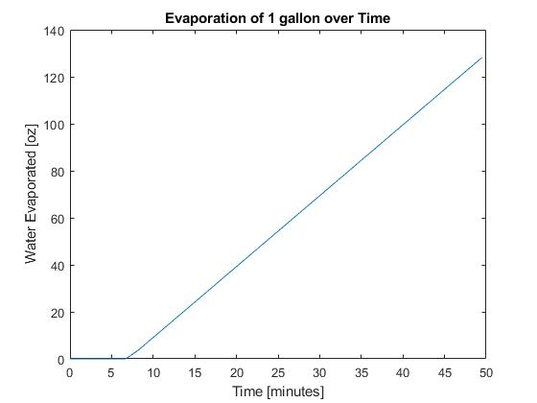

## Correct/Experimental Plot

x1 = [1:61]; %minutes before boiling

x2 = [62:99];

x3 = [99:504];

y1 = zeros(1,61);

y2 = (11/38)*[1:38];

y3 = (11/38)*[38:443];

plot(x1,y1,'b',[62],[0],'bo',x2,y2,'r',[99],[11],'ro',x3,y3,'m',[504],[128],'mo')

legend('Initial Heating','Boiling Point','Measured Condensation','End of Experiment: 11 oz','Continued Condensation','128 oz Evaporated')

title('Evaporation of 1 gallon over Time')

xlabel('Time [minutes]')

ylabel('Water Evaporated [oz]')

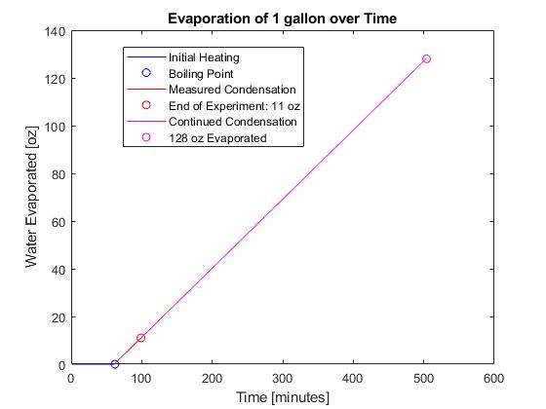

## Comparison Plot

xexp = [x1 x2 x3];

yexp = [y1 y2 y3];

plot(x0,boz,'b',xexp,yexp,'r')

title('Evaporation of 1 gallon over Time')

xlabel('Time [minutes]')

ylabel('Water Evaporated [oz]')

legend('Calculated: 49min','Experimental: 8hour 24min')

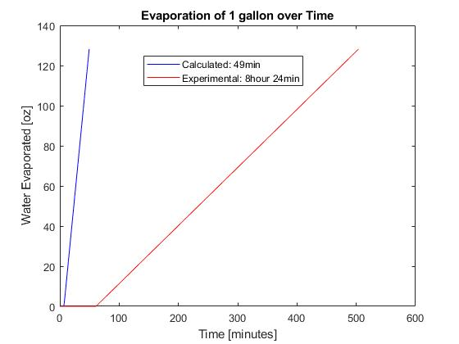

Published with MATLAB® R2017b

Here, the calculated initial time to boil is 400 seconds, and the calculated total time it takes for the entire mass (1 gallon starting from atmospheric temperature) to evaporate is 49 minutes and 28 seconds. This calculation is far from the experimental result. The actual rate at which one gallon of water fully evaporates was around 8.4 hours. The pot was not an actual blackbody, so the radiation was largely overestimated in the calculations. There was also a large amount of radiation lost due to imperfections in the mirrors. Insulating the pot on all sides except for the side with the reflected sunlight minimized the heat loss to the air enough to allow the water to boil. The ideal environmental settings used in the calculations were not realistic. Getting a gallon of water took 52 minutes to start boiling with an initial temperature of 27.6 degrees Celsius. From the steam collected, 11 ounces of water was condensed after 1 hour and 40 minutes of operation of the latest trial.

These results say that it takes 9.04 times longer to experimentally evaporate the water starting from atmospheric conditions than from initial calculations. This implies that the heat rate from the incoming reflected radiation and the outgoing convection of the actual experimental setup is far less than the initially calculated heat rate into the system. Before the system reaches boiling temperature, the initially calculated heat rate was 3.0291 kW and the experimental heat rate was 377.458 W yielding a 702.5% error. From boiling point until full evaporation, the initially calculated heat rate was 2.5731 kW and the experimental heat rate was 286.826 W yielding a 797.1% error. Experimental net heat rates were 12.46% (before boiling) and 9.47% (after boiling) of the initially calculated heat rates; this consistency of error proves the existence of an increasing heat loss by convection due to the increasing temperature difference as the water pot goes from environmental temperature to boiling temperature. Experimentally this increase in heat loss, as the water goes from 27.6 degrees Celsius to boiling temperature, was 90.632 W which is 24.01% of the initial heat rate. This is direct proof of the functionality of insulation around the pot which was added around the end of our period of design changes and testing trials, and this is the reason the water was finally able to reach boiling temperature (it failed to do so before the addition of insulation). Convective heat losses played a large role in preventing the reflected radiative heat addition from the mirrors and net heat rate into the system from achieving the project design goal.

# OPERATION OF FINAL DESIGN

With the pot of water covered with insulation on all sides except for the heated area, the heat loss was minimized enough to allow the focused sunlight to heat the side of the pot. This area was spray painted black to achieve more blackbody conditions of radiative heat transfer. The three mirrors pointed sunlight at this area, and the water eventually boiled from this heated side. The pressurized steam then flowed through the tube on the lid of the pot, and it condensed into clean water in the condenser.

One of the best parts about the functionality of the Solar Distiller is that it does not require any skills or prior knowledge in order to correctly assemble and operate. The device is created for users from a wide range of areas throughout the world. People from California to Africa can use this environmentally friendly device to provide them relief from the increasingly strong burden of water scarcity.

The only restraint on this product is the weather. The mirrors provide the most heat with direct/constant sunlight. On a cloudy day the product will take a longer time to distill water. The mirrors also tend to move if there is a large amount of wind. This changes the position of the focal point of the mirrors requiring more maintenance during operation. As this is a prototype, future designs would account for this defect.

# CONCLUSION

Our water distiller design consists of a tripod that holds the main water containing pot over three circular, concave mirrors. Each mirror is held up by its own stand and can be adjusted so that focal point of each mirror can remain on the water pot to provide the necessary heat flux required to evaporate the water held within. Condensate is collected at the top of the pot and passed through a pipe to a condenser. After condensing, the water is then stored for later use.

The mirrors were tested under various weather conditions. The most recent testing was successful in boiling the water, because there was plenty of sunlight and not too much wind. The focal point of the reflected sunlight was hot enough to light leaves on fire, so it was hot enough to heat up the side of the water pot enough to get a gallon of water boiling. The steam condensed just as planned in the condenser, and distilled water was collected.

We collected 11 ounces of water in 1 hour and 40 minutes which is a longer amount of time than we predicted in our calculations. Although the results aren’t ideal, we believe further improvements on the design could greatly increase the efficiency of the device.

To make the project work even better, the device could have three modifications.

1- Mirrors

The mirrors manufactured during this process were full of imperfections (bubbles/scratches). This greatly reduced the amount of heat we were able to direct at the boiler. Better mirrors could have been purchased or made using a different/less strenuous method (satellite dish coated in mylar). Also, to prevent movement from the wind, a stronger mirror stand could be created using 2x4’s and hinges.

2 - Direction of Sunlight

In this design, the mirrors pointed a the bottom/side portion of the pot. Because the light is being directed at the metal, there is a significant amount of heat lost. A better way to approach the heating process would be to raise the mirrors and point the sunlight down through a transparent lid directly at the water. This would create a faster boiling time.

3 - Larger diameter tubing

The tubing we used to connect the boiler to the condenser was small - about ⅝ inch ID. This size was chosen to match the inlet of the condenser we purchased. To increase the amount of steam collected over time, larger tubing could be used. This would increase the volume flow rate of the steam to the condenser and lead to a faster rate of condensation.

Although the experimental results we gathered were less than we initially calculated, the Solar Distiller proved to do exactly what it was intended to do. We were able to boil salt water using the three parabolic mirrors and extract distilled water from the steam. With further improvements, the Solar Distiller could provide even more efficient, environmentally friendly relief for victims of water scarcity throughout the globe.

# REFERENCES

[1] Gamatie, Abdoulaye. *Computing in Research and Development in Africa: Benefits, Trends, Challenges and Solutions*. Springer, 2015.

[2] Mearian, Lucas. “IBM's Solar Concentrator Can Produce Energy, Clean Water and AC.” *Computerworld*, Computerworld, 24 Sept. 2014, www.computerworld.com/article/2687236/ibms-solar-concentrator-can-produce-energy-clean-water-and-ac.html.

[3] “Scarcity, Decade, Water for Life, 2015, UN-Water, United Nations, MDG, Water, Sanitation, Financing, Gender, IWRM, Human Right, Transboundary, Cities, Quality, Food Security.” *United Nations*, United Nations, [www.un.org/waterforlifedecade/scarcity.shtml](http://www.un.org/waterforlifedecade/scarcity.shtml).

[4] “Thermophysical properties of seawater,” MIT code version: 20 Feb. 2017, web.mit.edu/seawater

# Appendix A1. PROJECT MANAGEMENT

The Solar Distiller had an 8-month management plan that include the Fall and Spring semesters. After completion of the project, the device was fully optimized, assembled and tested. As mentioned in the “Design Process” section, there were two initial designs that were ultimately developed to become the final design. The first six weeks of the semester were dedicated to their research and design.

**Semester I (2017)**

Preliminary Calculations (October 20th - November 3rd)

After the Solar Distiller concept was agreed upon, research went in to the solar distiller’s potential. Collecting data from online examples of solar desalination in survival videos went into finding realistic calculations. Although this was helpful in gauging the practicality of the product, we needed specific measurements to produce any meaningful calculations.

Design Basics (October 31st - November 30th)

When we had the concept and realistic capabilities of the design, we then began figuring out how to build the distiller with a feasible and realistic approach. This process involved comparing different products already on the market and exploring the possibility of manufacturing parts ourselves vs. buying them from the provided vendors. Each member of the team was given a separate function of the overall design to research. Using separate research and the guidelines laid out in the Design Objectives section, the general design was mapped out.

Parts (November 27th - December 15th)

After the design was fully conceptualized, the parts that we could afford to buy were found online. This includes the Tripod, aluminum pot, condenser, and mirror stands. The materials necessary for the parabolic mirrors, which we will be building ourselves, were found from various vendors.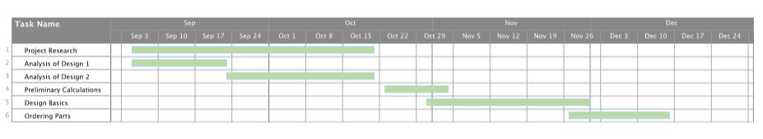

Figure 1: GANTT chart for semester 1.

**Semester II (2018)**

Construction (February 10th - March 26th)

Building the three parabolic mirrors was the first major goal of the second semester. This was possibly the most physically difficult part of the project and required careful workmanship from the entire team.

Assembly (March 26th - April 1st)

With the parabolic mirrors fully constructed, the entire device could be assembled. This required some small changes to fully construct a stable device. More parts were bought (ie. chain, plastic edging, silicon lid) to ensure full functionality

Testing (April 6th - April 23rd)

Testing the functionality of the device was complicated as this phase was during colder months and the device relies entirely on solar radiation. The first couple testing attempts were only for the mirrors. We needed to see if the mirrors had the ability to provide enough heat to boil water. We concluded that the mirrors were strong enough since they were able to almost instantly burn wood, but we weren’t able to boil the water in our boiler.

To fix this issue, we made a few minor tweaks over the next few testing attempts. To better heat the water using the solar energy from the mirrors, we insulated the periphery of the pot, bottom and lid. We also painted the pot black on the portion that was exposed to the solar radiation. This allowed for more absorption and more efficient heat transfer. We also lowered the elevation of the condenser to account for condensed steam in the tube. The tweaks we made over time allowed us to eventually boil the water and ultimately collect the steam through the condenser.9

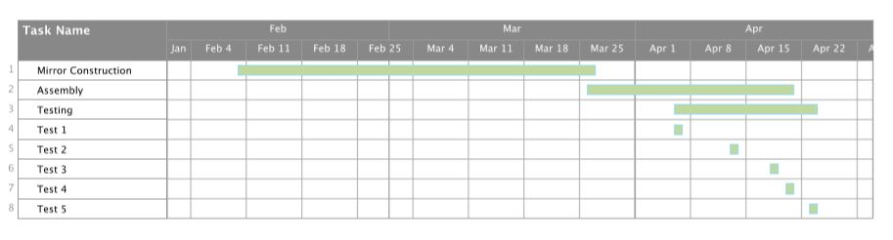

Figure 2: GANTT chart for semester 2.

# Appendix A2. BUSINESS MODEL CANVAS

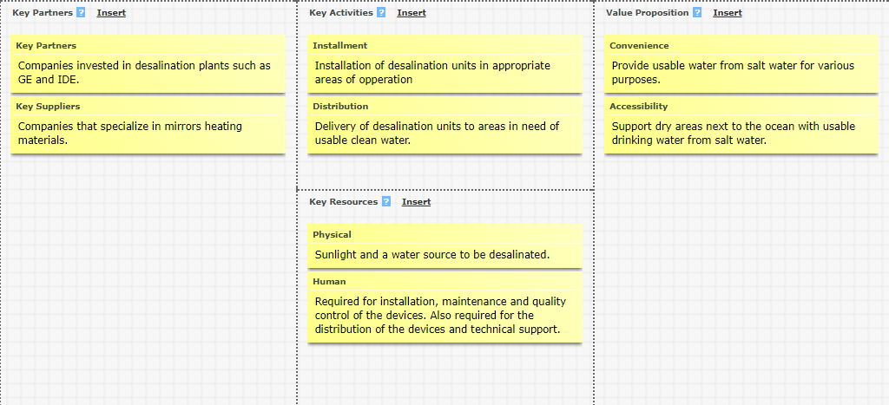

Figure 3: Business Model Canvas - Top Left

Figure 4: Business Model Canvas - Top Right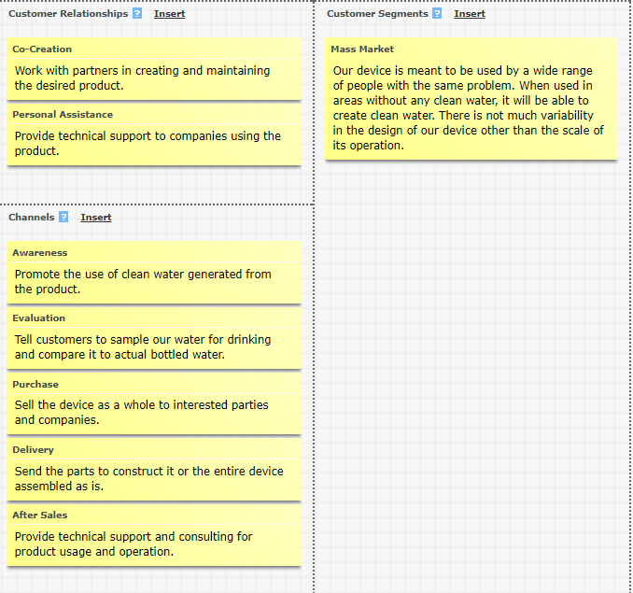

Figure 5: Business Model Canvas - Bottom Left (Up) And Bottom Right (Below)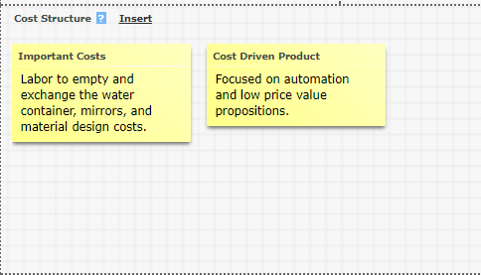

# Appendix B. PARTS LIST/BUDGET

The budget of this project was calculated by looking at the project in a few main parts. The boiler will be based off a cooking pot suspended off the ground using a tripod. The boiler will be painted black and wrapped in insulation and Mylar. From the boiler the heated steam will travel into a copper condenser where it will be converted into distilled water and then collected. The mirrors have the most assembly involved with parts such as the Mylar, fiberglass, mic stands and clips, and the landscaping edging. The money is saved in making the mirrors because 90%, if not all, of the budget could have gone to them alone. The biggest expense will be the copper condenser, but the money is well spent on saving time and frustration of making and machining one from raw materials. In addition, it is guaranteed to work from the moment it is obtained, thereby allowing our group to focus more on fine tuning the placement and assembly of the mirrors. The total budget is $631.71. We ended up about $30 over budget because of unforeseen problems that were mostly related to the amount of material needed to make everything, including redoing parts such as mirrors that turned out less than stellar. All in all, we went about 5% over budget, which is definitely reasonable, and planned due to the fact that we originally estimated about a $550 budget. This allowed room for the last minute purchases. The itemized parts list can be seen below in Table 1.

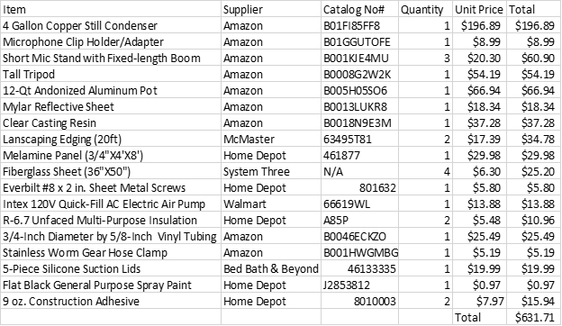

Table 1: Parts List and Estimated Budget

# 

# **Appendix C. DRAWINGS**

# 

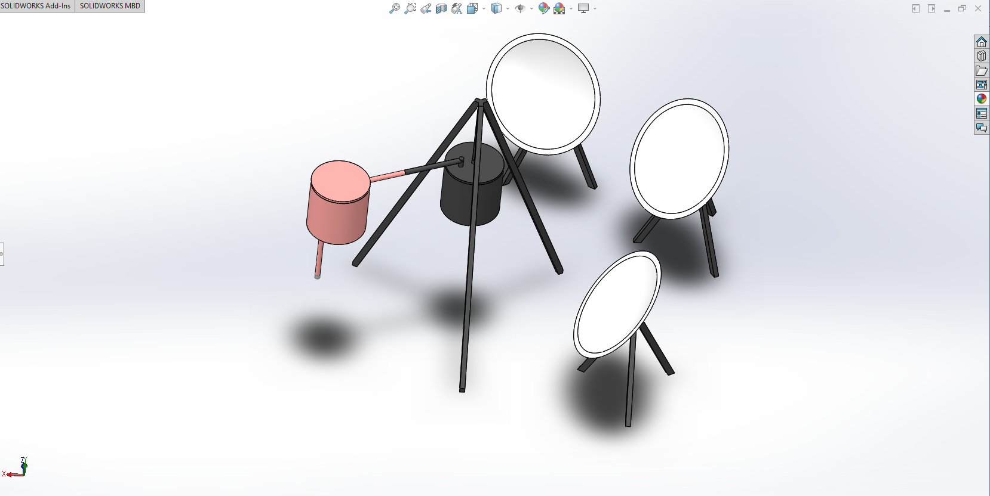

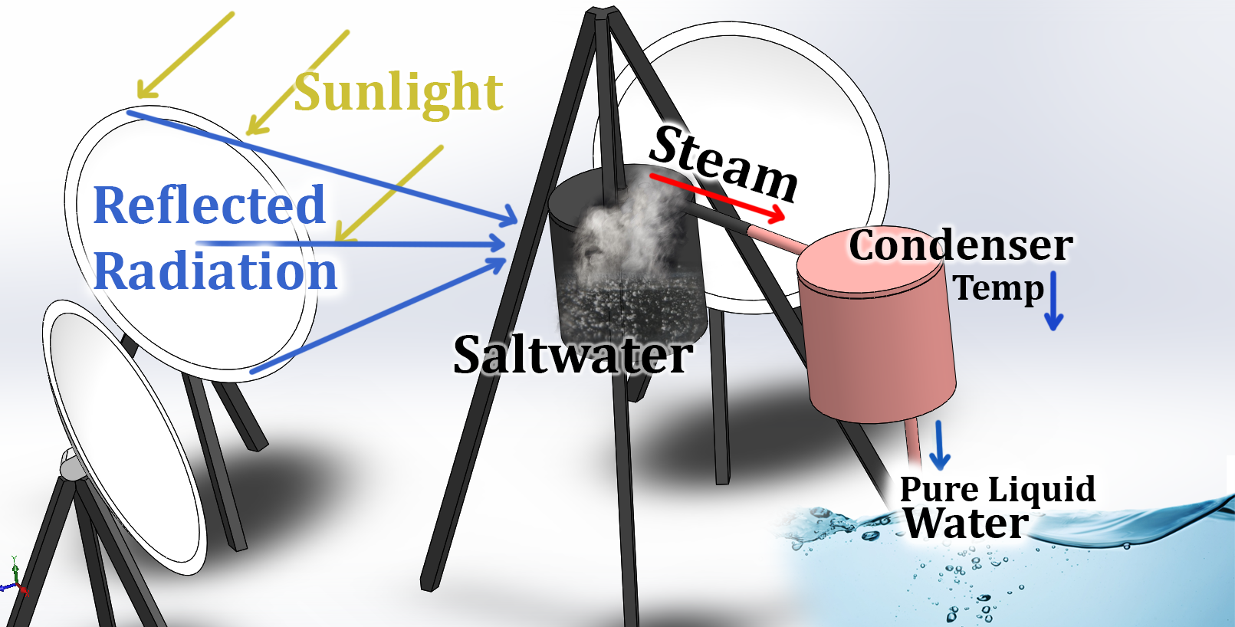

Only parts to be self-manufactured are the mirrors, 26 inches in diameter.

Large tripod legs are 60 inches long.